**MESD LMS Documentation – Teacher should see other students in other courses**

**Purpose**

To facilitate viewing other students in the same course category as yours.

**Background**

This module handles requests directly from Educators within the Moodle system, allowing Educators to view other students in other courses.

**Usage**

**Viewing other students in other courses**

1. Log in to Moodle as an Educator
2. Open your block drawer on the right side of your screen.

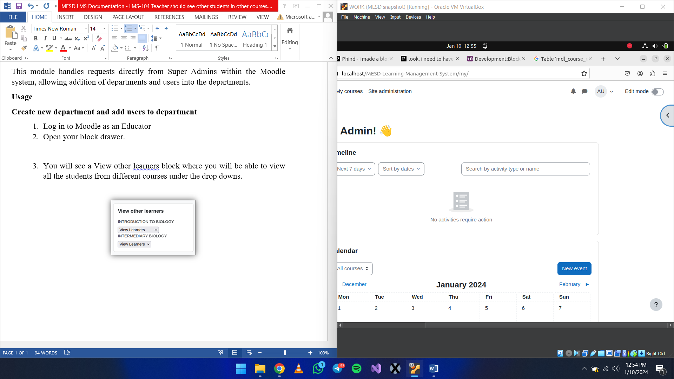

1. You will see a ‘*View other Learners’* block where you will be able to view all the students from different courses under the drop downs.

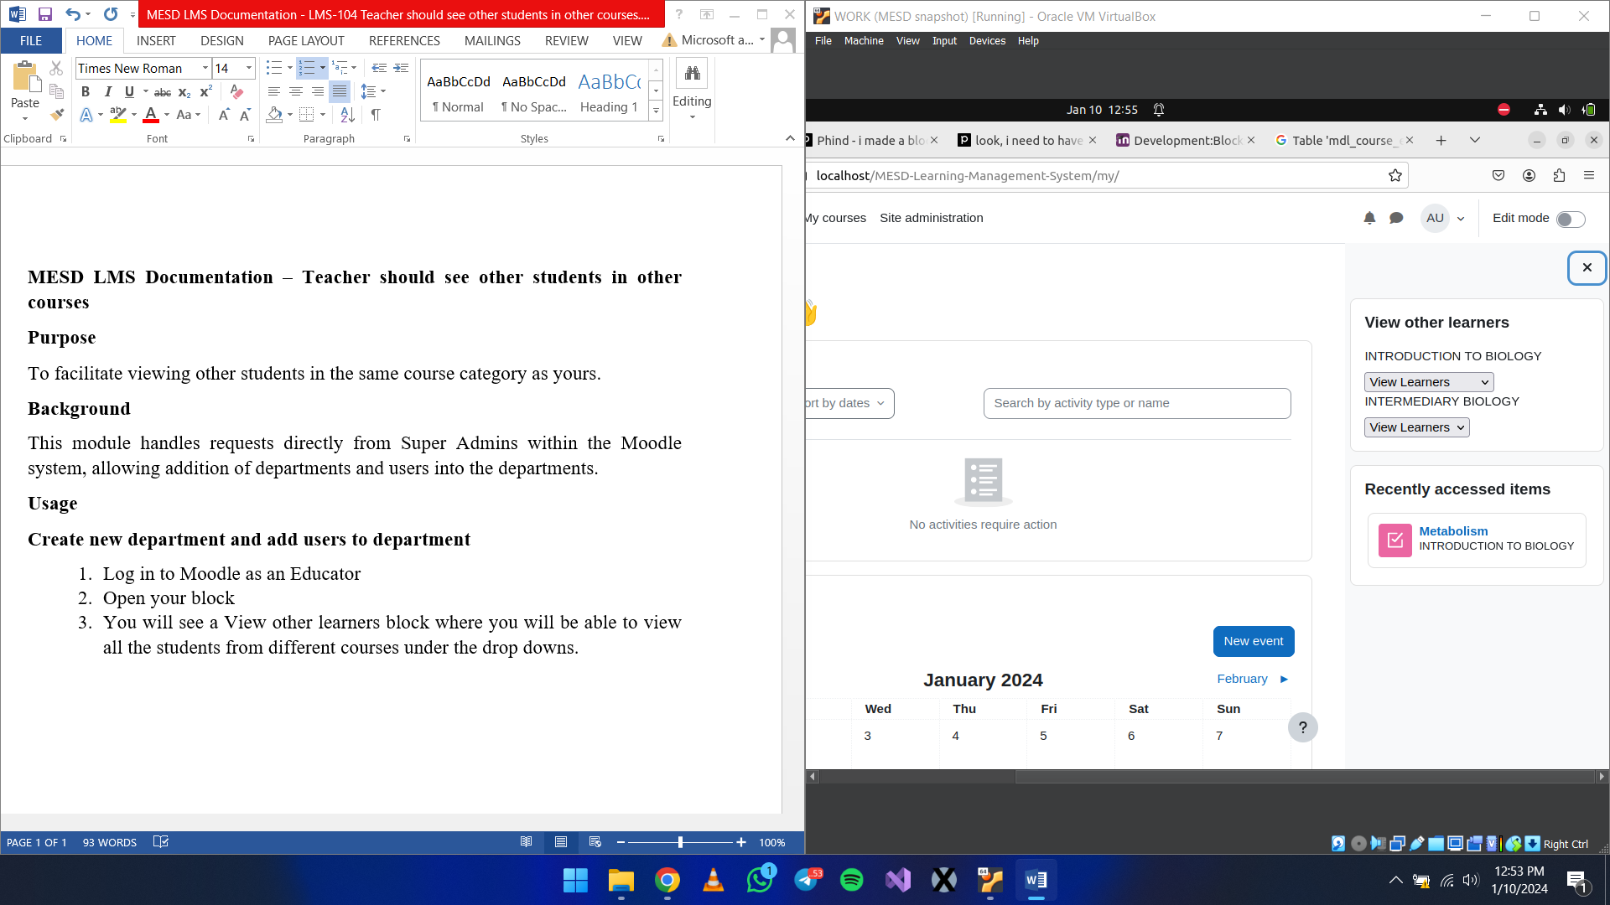

**Adding the ‘View Other Learners’ block**

1. Log in as a user with block permissions
2. Go to the tab where you want to add the block.
3. Turn on edit mode
4. Open the block drawer and select *‘Add a block’* then select ‘View Learners’*.*

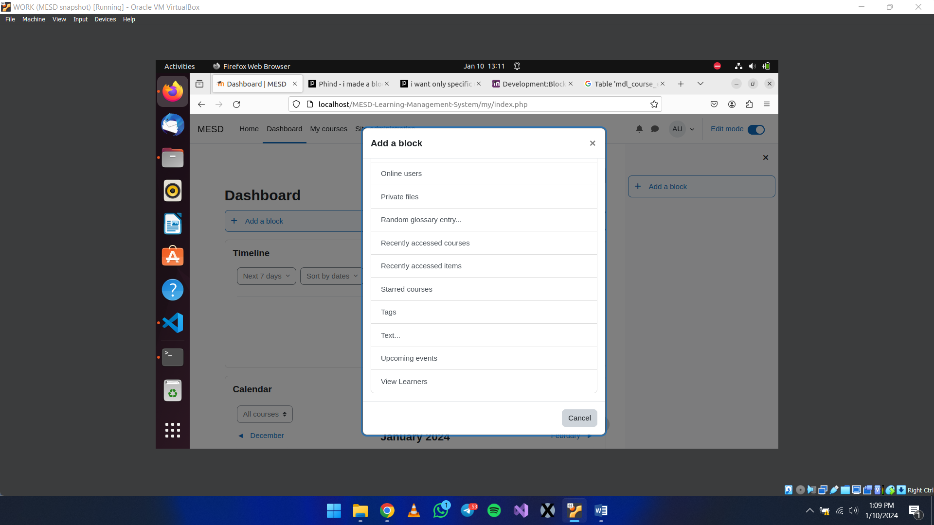

**Developer’s Information**

Capabilities

block/view_learners:useviewlearners : Allows the user to view this block